INFORMATION SHEET FOR PARTICIPANTS

Ethical Clearance Reference Number:

YOU WILL BE GIVEN A COPY OF THIS INFORMATION SHEET

Study for new Tablet Games

We would like to invite you to take part in our study and help us develop new tablet games. They measure different processes such as how attentive you are or how quick you learn. We want to find out if children like you who are between the age of 9 and 11 years, enjoy these games!

What will happen if I take part?

If you choose to help us, you will play tablet games and let us know if you like them! The tasks consist of animated cartoons or short films. In the game, you can travel into different worlds in a special machine, like the one showed below.

The magical worlds will include the dinosaur era or a pirate era:

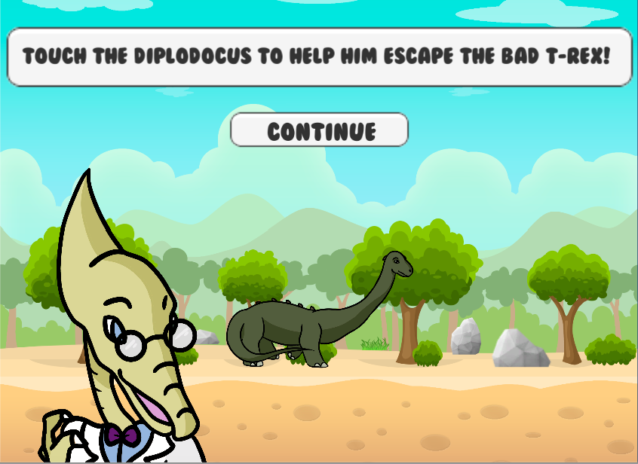
After your parents agree for you to take part, you will play these games at home on your tablet or on the internet browser. You should pay attention to instructions and try your best to play the games to the best of your ability! Playing the games will not take longer than an hour.

After you play on the tablet, we may ask you some questions about the games e.g. whether you had fun while playing or what would you change about them.

Do I have to take part?

Participation is completely voluntary. You should only take part if you want to and choosing not to take part will not disadvantage you in anyway. Once you have read the information sheet, please let us know if you have any questions. If you decide to take part, we will ask your parents to sign an online consent form for you.

What if I change my mind about taking part?

You are free to stop playing at any point of the project, without having to give a reason.

